Project Design Phase-II
Data Flow Diagram & User Stories

Date | 03 October 2022
Team ID | PNT2022TMID00332
Project Name | Project - AI based localization and classification of skin disease with erythema
Maximum Marks | 4 Marks

Data Flow Diagrams:
A Data Flow Diagram (DFD) is a traditional visual representation of the information flows within a system. A neat and clear DFD can depict the right amount of the system requirement graphically. It shows how data enters and leaves the system, what changes the information, and where data is stored.
Example:

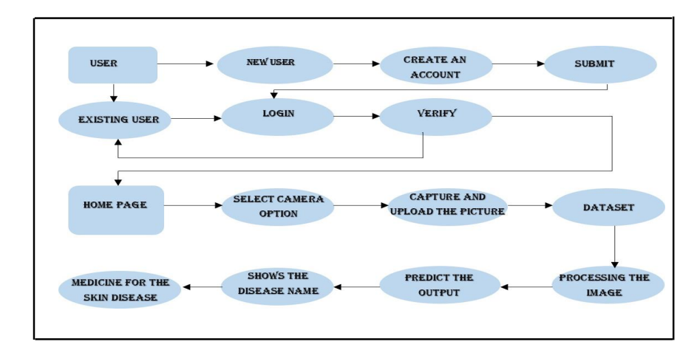

User Stories
Use the below template to list all the user stories for the product.
User Type | Functional Requirement (Epic) | User Story Number | User Story / Task | Acceptance criteria | Priority | Release
Customer (Mobile user) | Registration | USN-1 | As a user, I can register for the application by entering my email, password, and confirming my password. | I can access my account / dashboard | High | Sprint-1
 | Login | USN-2 | As a user, I can log into the application by entering email & password | I can login using my E-mail ID accounts or user credentials | High | Sprint-1
 | Dashboard | USN-3 | As a user, I can view the page of the application where I can upload my images | I can register & access the dashboard | High | Sprint-2
Customer (Web user) | Registration | USN-4 | As a user, I can login to web dashboard just like website dashboard. | I can register using my username and password | High | Sprint-3
 | Login | USN-5 | As a user, I can login to my web dashboard with the login credentials. | I can login using my user credentials. | High | Sprint-3
 | Dashboard | USN-6 | As a user,I can view the web application where I can upload my images and the | I can access my account/dashboard | High | Sprint-4
 |  | USN-7 | As the user , I will submit the images for prediction. | I can access my account/dashboard | High | Sprint-4
Administrator | Login | USN-8 | Collect the required data for the detection of skin disease. | I can login to the website using my login credentials. | High | Sprint-5
 | Dashboard | USN-9 | Build the model using the normal classifiers to classify the images | I can access my dashboard | High | Sprint-5

